Nihaal Sudhir Karhadkar F003 M.SC.cs sem 1

Cyber security and Digital Forenscis Practical4 _ Implement A brute Force attack and a virus

1. Implement a brute force attack using java / python

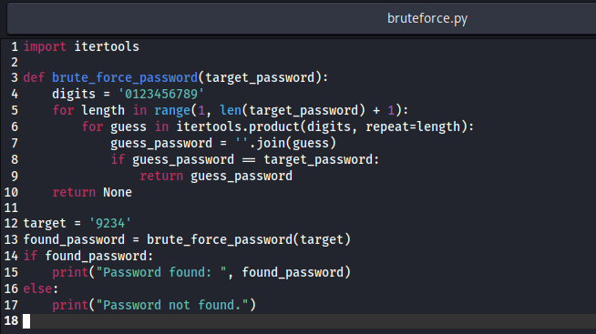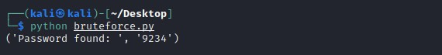

1. Implement a virus using java / python

